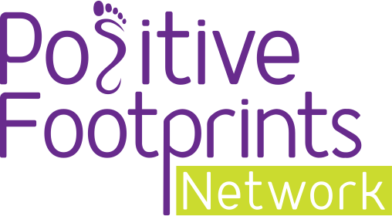
Completing the Raising Aspirations Programme

Celebrating the journey with Positive Footprints
Congratulations parents and guardians, we are delighted to let you know that your child has successfully completed the Positive Footprints Raising Aspirations programme!
Positive Footprints work with schools across the UK to open up the world of work for children and build resilience, character and self-esteem for young people.

Your child has completed a 12-hour careers-led learning programme and has watched a range of careers videos from a variety of people to inspire their career path.
From everyone at Positive Footprints we would like to offer a huge well done!

The work
Your child has learned about the difference between technical skills and personal qualities as well as create a CV, cover letter and much more that will help them apply for jobs in the future.

They will be able to tell you about all the brilliant activities they have completed as part of the programme and we hope they enjoyed participating half as much as we enjoyed creating it!

Share our story
We love seeing pictures and videos of what our pupils have learned after completing our programme, so please share anything you have got with us on Twitter @positive_fpn using the hashtag #RaisingAspirations

