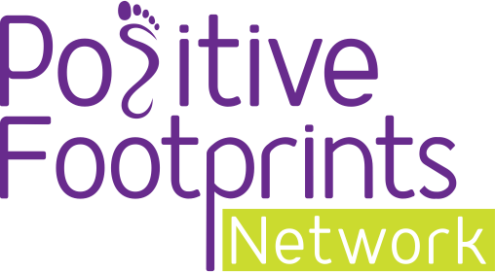
Your blog template

We’re Raising the Aspirations of our Year [no.] Students!

This year, we are inspiring our students with the award-winning Raising Aspirations programme from Positive Footprints!

The Raising Aspirations programme aims to widen our student's horizons by expanding their knowledge of the world of work.

It will give them the skills and qualities needed for all kinds of different careers and it will help build their resilience too.

The Raising Aspirations programme has been created by Positive Footprints and is Ofsted rated ‘Good’.

The success has seen this innovative 12-hour programme be delivered to hundreds of primary school children throughout the UK.

Children will learn about careers through a range of activities including videos from industry experts to writing their very own CV!

It is essential that our children learn these things early so that when they are ready to pick their GCSE's, go off to college, university or even star an apprenticeship, they have a better understanding of the careers out there for them.

We are proud to be completing the Raising Aspirations programme and inspiring our children to reach for the stars.

To find out more about the Raising Aspirations programme visit www.positivefootprints.co.uk

