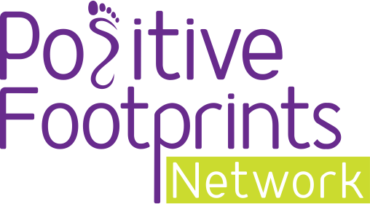
Starting the Raising Aspirations Programme

Coming soon to a school near you…
Parents and guardians, we are delighted to let you know that your child’s school has chosen to run our award-winning Raising Aspirations Programme.

We are Positive Footprints and we work with schools across the UK to open up the world of work for children and build resilience, character and self-esteem for young people.

Our 12-hour course consists of three modules full of lessons and activities to enable your child to think about their future, what they could be and how they can fulfil their potential. We want to enable your child to DREAM BIG!

So if your child comes home talking all things careers, interviews and CVs that’s because Positive Footprints is helping lay the foundation to help them achieve their dreams.

Meet the Junctioneers!
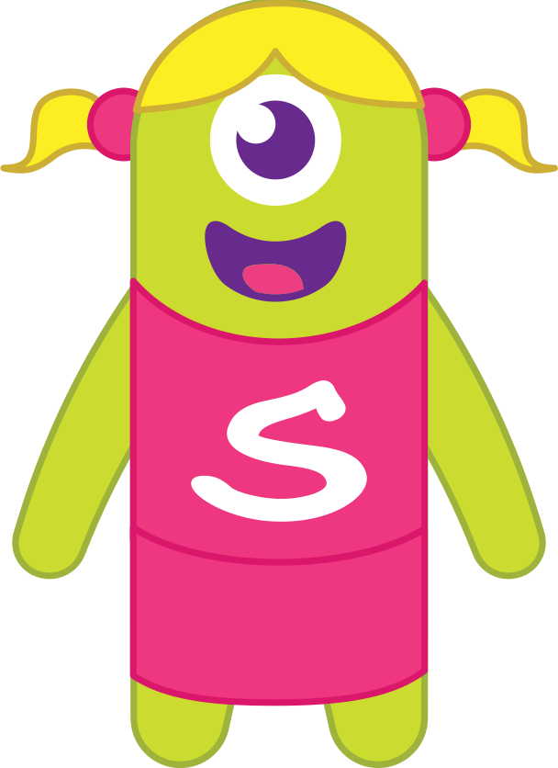
Character building starts with characters that’s why at Positive Footprints we have four characters that will each take this exciting journey with your child.
We have Jamie the Team Leader, Quentin Qualities, Sally Skills and Ollie the Overcomer.

The children will become familiar with these characters as they appear throughout the programme, so if you hear these names mentioned at home it’s not a new child in school, it’s one of our friendly Junctioneers!

Careers, Careers, Careers
With so many different careers to choose it’s hard to know what direction to head in, that’s why it helps to hear from someone who has been there and done it!

At Positive Footprints, we have created a host of videos with industry experts from a variety of sectors to talk about their career path.

These people all come from different backgrounds and their journey to the top of their chosen professions will be used to inspire your child.
Seeing is believing and your child will meet a variety of people who they could emulate including engineers, hairdressers, a bridal shop owner, a nursery manager and because the sky is the limit RAF personnel.

Share our story
We love seeing pictures of what our pupils are learning during our programme, so please share their work on Twitter @positive_fpn using the hashtag #RaisingAspirations

